DuraCase™

User Manual
By G9 Design

Before Use, Please Read The Following User’s Manual
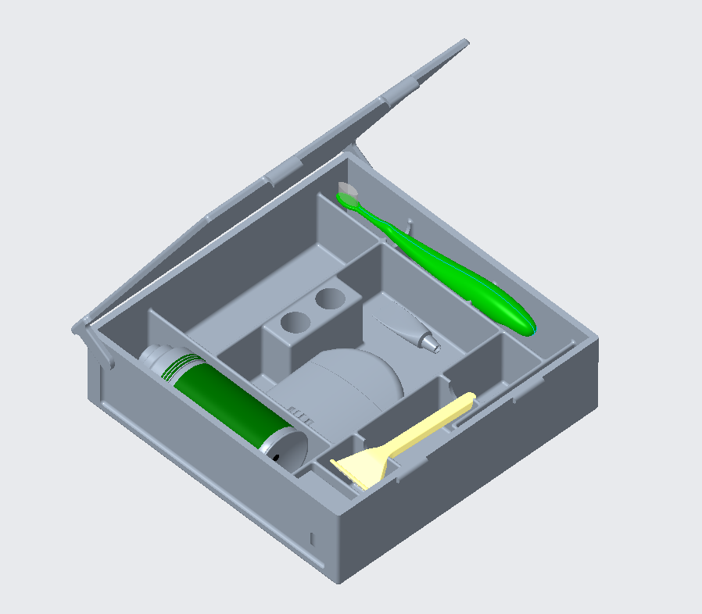
DuraCase™

Table of Contents
Product Assembly………...3
Set-up and Use……………4
Maintenance………………5
Safety Information………..6
Warranty Information……7
Service Center…………….8

Assembly

The DuraCase requires very little assembly so you can focus on what really matters! The product itself comes out of the box assembled, all you must do is add your toiletries of choice!

Your DuraCase Toiletries Case comes with (1) Base and (1) Lid.

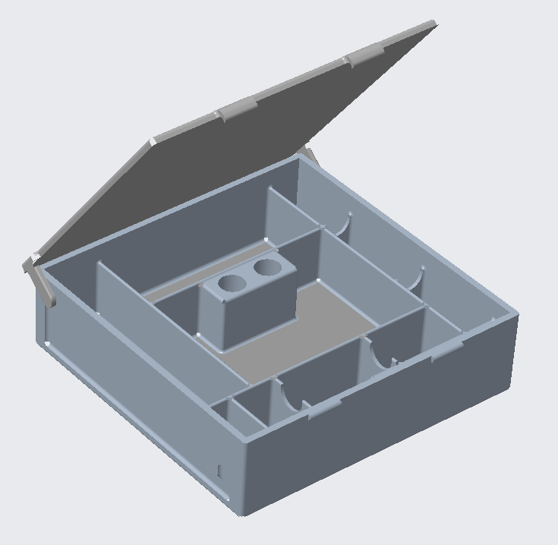
Lid
Base

Setup and Use

To properly set up your DuraCase Toiletries Case, follow the diagram shown below. The DuraCase was specially designed to accommodate your toiletries with neat and methodical compartmentalization. The DuraCase can hold (1) Regular Size Toothbrush (1) Travel Size Deodorant Stick (1) Regular Size Razor (1) Regular Size Floss (1) Travel Size Comb (1) Travel Size Tube of Toothpaste (1) Travel Size Shaving Cream

The DuraCase was designed with an additional compartment to be used at your leisure. Use it as you wish!

The two holes placed in the middle of the DuraCase allow you to use them as a stand for your toothbrush and razor. Simply place the bottom end of your razor and your toothbrush into the holders to keep them elevated and allow them to dry.

Using the DuraCase outside of it’s intended design may result in damage to the product, or damage to your personal belongings. Please use only as instructed in this user’s manual.
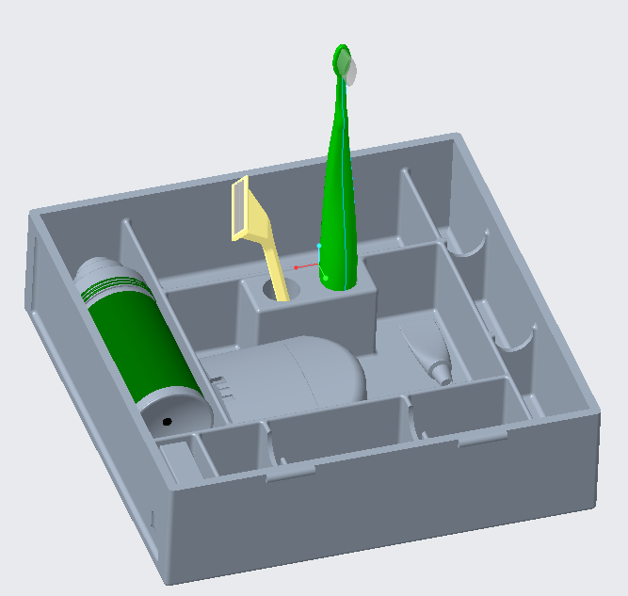
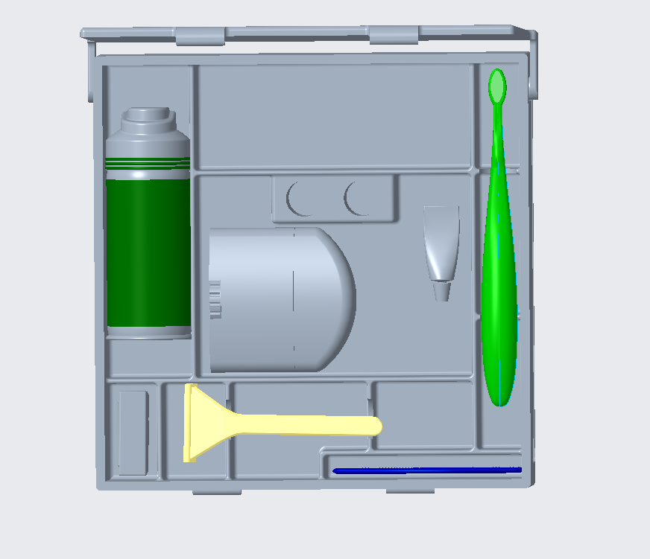

Maintenance

The DuraCase requires very little maintenance! It can be easily cleaned with a warm cloth and dish soap after extended usage. First, empty the case of all your personal toiletries and belongings. Then simply wet a cloth with warm water and add a small amount of dish soap and clean the inside and outside of the case. This case is also dishwasher safe.

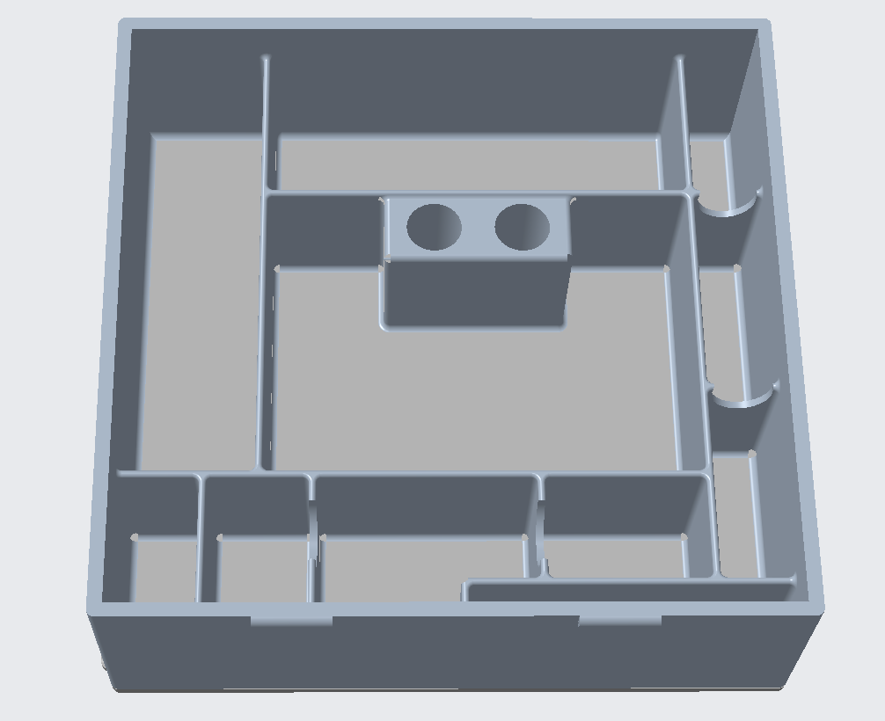

Safety Information

This product was designed for the sole purpose of storing toiletry items. Any usage outside of this product’s intended design may result in injury, property damage, or product damage. The DuraCase Toiletries case is dishwasher safe. It can be washed by hand or placed in the dishwasher to clean. The DuraCase Toiletries case is made of food safe, ultra-durable Polyphenylsulfone (PPSU), making it highly resistant to impacts, chemicals, and high temperatures.

Use the product as specified by this User’s Manual. Failure to do so may result in a voided warranty.
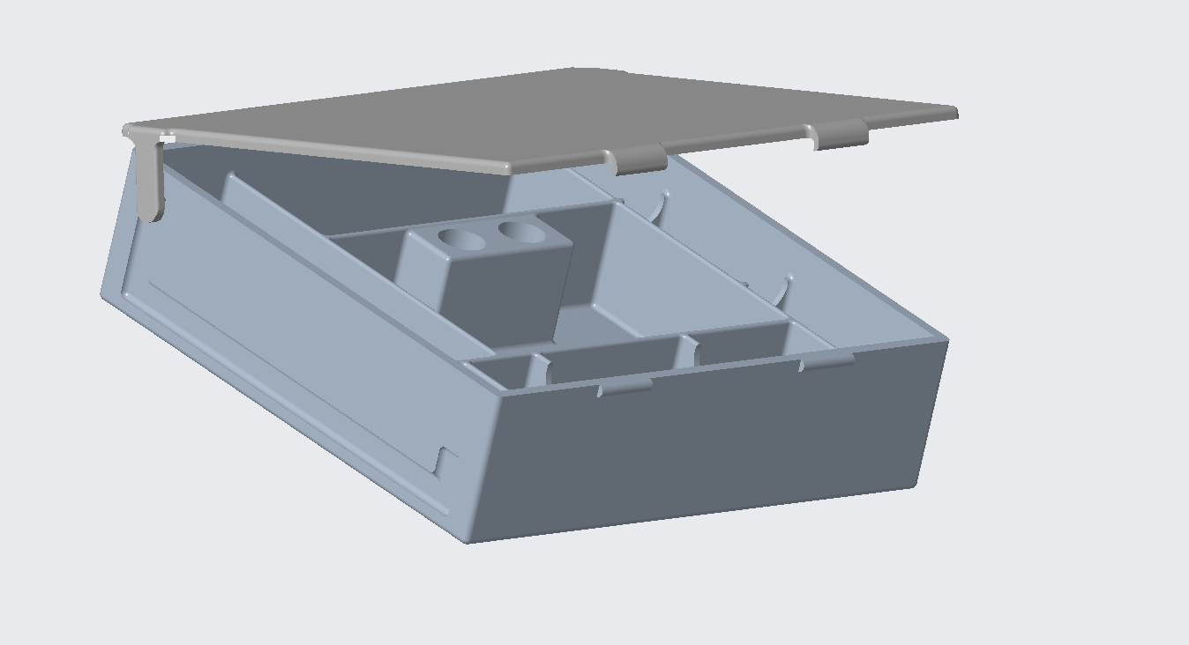

Warranty Information

The DuraCase Toiletries case is covered by a (1) year replacement warranty. If your product arrives broken, or breaks at no fault of your own, a completely new DuraCase will be sent to you free of charge! If you find that you’re unsatisfied with your DuraCase in any way, ship it back to us for a full refund, shipping is on us!

Using the DuraCase outside of its intended design may result in a voided warranty. G9 Design is not responsible for any damage associated with the usage of the DuraCase. Please have proof of purchase or have a credit card number associated with the purchase when making a warranty claim.

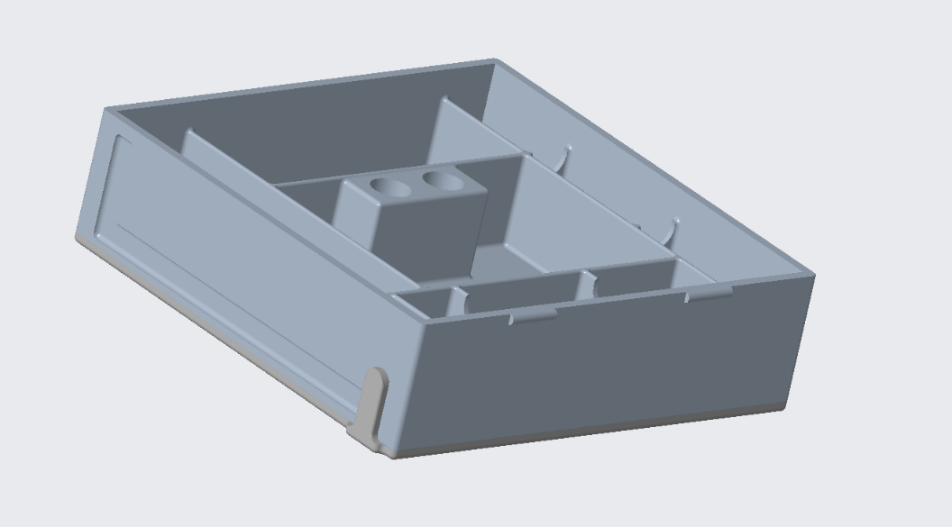
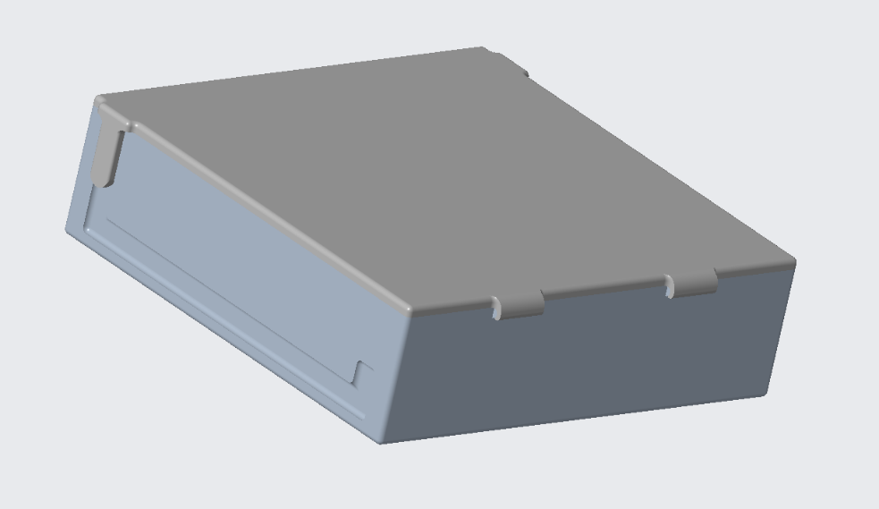

Service Center

The information below is current and correct as of December 2021. However, to get our most up-to-date contact information, please refer to the website below.

Website
https://webpages.uncc.edu/jholde20/project1.html

Phone Number:
704-DRA-CASE

Address
9201 University City Boulevard.
Charlotte, NC 28223

Disclaimer*
Due to the currently ongoing COVID-19 pandemic, some customers may experience delays with customer service. Please know that we value all our customer’s time and money, and that we are doing our best in these unprecedented times. Our service center is open 24/7 except for bank holidays. Thank you for your understanding and thank you for purchasing a DuraCase Toiletries Case. ~G9 Design

Owen Rettke
Management & HR
orettke@uncc.edu

Corbett Webster
CAD Design
wwebst13@uncc.edu

Julian Nicholson
CAD Design
jnicho70@uncc.edu

Joel Holder
IT, Website Design
jholde20@uncc.edu

